Title: Temporal and Spatial Shifts in Gun Violence, Before and After a Historic Police Killing in Minneapolis

**Authors:** Ryan P. Larson1*, N. Jeanie Santaularia2, and Christopher Uggen1

**Affiliations:**

1University of Minnesota - Twin Cities, Department of Sociology.

2 University of North Carolina, Carolina Population Center.

**Abstract:** In 2020, the United States experienced major social unrest in response to police killings, as well as a rise in the homicide rate but not the overall crime rate. This report uses Minnesota Hospital Association discharge data to evaluate the rate of firearm-related injuries occurring after the murder of George Floyd on May 25th, 2020. Interrupted time-series models indicate a significant increase in weekly firearm assault injuries post-murder, followed by a decrease, albeit not to pre-murder levels. Fixed-effects panel specifications corroborate this temporal pattern, while also documenting the spatial heterogeneity in the effect across Minneapolis, with more disadvantaged, historically Black communities experiencing the brunt of the increase in firearm assaults. These temporal effects remain after adjusting for changes in police activity and pandemic-related restrictions, indicating that the increase in violence was not a simple byproduct of post-killing changes in police behavior or COVID-19 response. These findings show how the deleterious consequences of police killings and social unrest are disproportionately borne by underserved communities.

**One-Sentence Summary: Rates of firearm assaults increased after the police killing of George Floyd in Minneapolis, MN, primarily in more disadvantaged communities.**

**Main Text:**

During the past year, the United States experienced major social unrest in response to several high-profile police killings of Black civilians, which represent a fatal dimension of the enduring structures of racial domination in the criminal justice system (1,2). These high-profile killings catalyzed the growing social movement #Blacklivesmatter, which brings attention to the long history and contemporary realities of police violence and brutality, particularly against Black people (3,4). These social tensions came to a head in Minneapolis, Minnesota after the highly publicized murder of George Floyd on May 25th, 2020 by police and the subsequent protest and social unrest. A widely reported spike in gun-related crime emerged after the murder, alongside claims that the rise in violence was due to changes in local police behavior (“depolicing”) in response to protest and social unrest (5,6) and a broad national increase in homicide (7).

**Background**

Research and public discourse in the aftermath of such violence has emphasized the temporal and spatial pattern of subsequent violent crime (8,9). Studies following the police killings of civilians have focused on the so-called ‘Ferguson effect’ following the death of Michael Brown in Ferguson, MO. Despite speculation that violent crime increased, particularly gun violence, there was no increase in homicides or other types of violent crime in St. Louis, Missouri (8,9). After the unrest following Freddie Gray’s arrest and killing in Baltimore, however, shootings and homicides increased in the following three months (10). To date, the studies investigating these trends and associations have largely analyzed data reported directly from police departments. These data are limited, however, due to 1) selectivity associated with systemic racial biases and the overrepresentation of communities of color in police and court data; and 2) potential misclassification of gun violence due to changes in policing, and subsequent detection and categorization of crime events, in a time of disruption (11). Moreover, the willingness to report to the police is likely diminished in the aftermath of police violence, especially in communities that are overpoliced and disproportionately impacted by gun violence (12). These points highlight the need for alternative data sources to track gun violence and crime independent of data collected by police. Although hospital data are not free of such biases, injury reports offer an independent and potentially more accurate source of information about violent injury.

In light of this background, the current analysis seeks to understand: 1) the temporal and spatial pattern of gun violence injuries in Minneapolis, pre- and post- the police killing of Mr. Floyd; 2) whether the patterns of gun violence injuries mirror prior work in Ferguson, Baltimore or elsewhere; and 3) to the extent that we observe a “Minneapolis effect,” whether disadvantaged communities experienced the greatest change.

**Results**

***Temporal Pattern of Firearm Assault Injuries***

Figure 1 displays the weekly incidence of gun assault hospital discharges in Minneapolis from 2016-2020. We observe a sharp increase in the firearm assault injury rate from about .005 per 1,000 residents to .044 per 1,000 residents after the police killing of George Floyd, an eight-fold increase. After an initial spike, the rate fell to levels consistent with the pre-killing period.

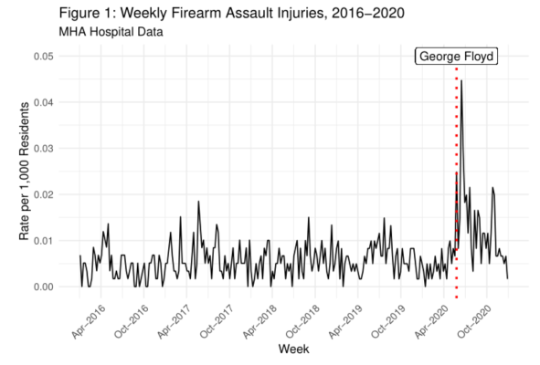

***Spatiotemporal Pattern of Firearm Assault Injuries***

While the results in Figure 1 describe the temporal pattern, we then disaggregate the data to the Zip Code Tabulation Area (ZCTA) - week level to analyze the spatiotemporal variation in the rates of firearm assault. Figure 2 displays the firearm rates by Zip Code Tabulation Area (ZCTA) and period. The temporal pattern apparent in Figure 1 emerges, but only for certain ZCTAs. Specifically, areas already marked by higher gun violence in the pre-treatment period, experienced more variation across the time periods as compared to ZCTAs with very low firearm assault incidence.

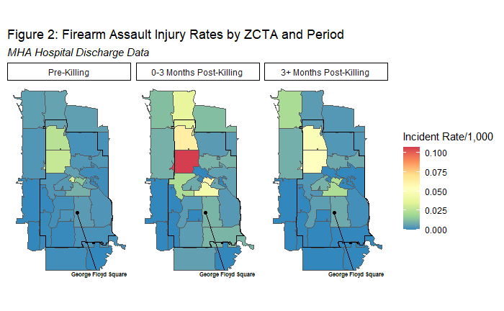

***Interrupted Time Series Models***

Table 1 presents interrupted time series models of the firearm assault injury rate in Minneapolis from 2016-2020. Each model includes a time indicator for each period[1] of analysis, as well as controls for seasonality and police behavior. Model 2 is estimated on disaggregated weekly Zip Code Tabulation Area data, and includes ZCTA fixed effects to account for time-constant unobserved heterogeneity. Controlling for seasonal expectations, Model 1 indicates that the rate of firearm assault injuries rose in the three months post-killing, with an increase of .014 firearm assaults injuries per 1,000 residents over those three months on average. In the remaining weeks after the twelve-week post-killing period, the rate declined .004 in this period, indicating that the rate did not return to pre-killing levels after the initial spike. In Model 2 these results are corroborated with within-ZCTA comparisons, with the post-killing period marked by a .97 increase in firearm assault injuries incidents per 1,000 residents, followed by a decline (-.35) in the period three months post-killing. Upon controlling for changes in police behavior in both models, the event time indicators remain largely unaltered in direction or magnitude, suggesting that changes in local policing did little to drive the increase in gun violence. If changes in police behavior were a key driver of this post-killing increase, then the inclusion of police measures should have attenuated the post-killing effect, which we do not observe. This analysis provides evidence of a “Minneapolis effect,” as the firearm assault injury rate increased above and beyond seasonal expectations, but not one driven by changes in police behavior or COVID-19 related state policy changes.

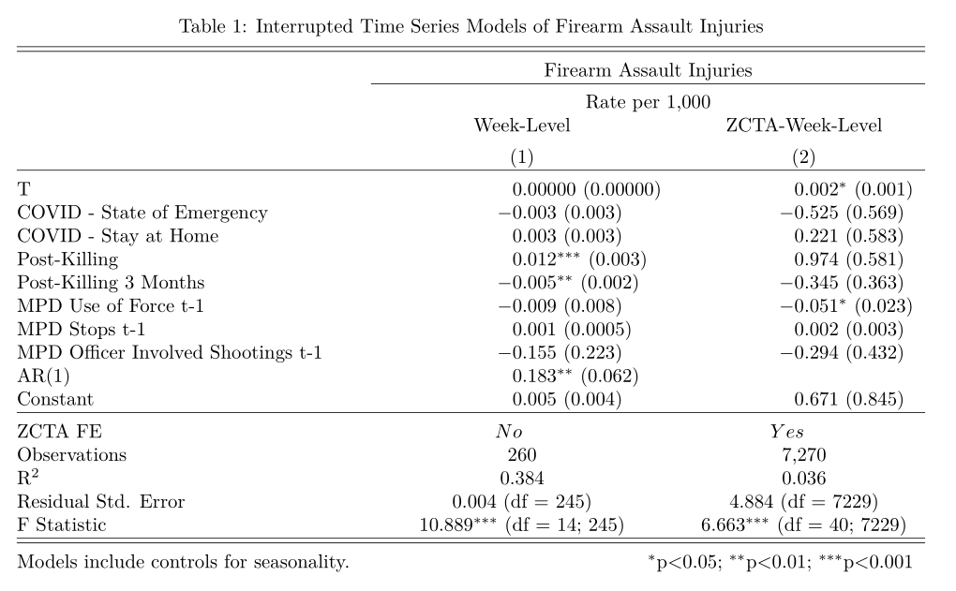

***Spatial Heterogeneity in Post-Killing Effects***

Figure 3 displays neighborhood-specific coefficients from a fixed-effects panel model. The model includes interaction terms between the ZCTA-fixed effects and the time indicators, which allows the time effects to vary by ZCTA.[2] In other words, the choropleths are shaded with the increase (red), or decrease (blue), in firearm assault rates, net of other factors, as compared to the preceeding period. Specifically, ZCTAs 55411, 55412, 55404, and 55415 - historically Black ZCTAs and marked by significant social disadvantage - experienced significantly higher increases than other ZCTAs.[3] In addition, the ZCTAs with significantly higher post-killing effects tended to also be those with the highest incidence of firearm assault injury in the pre-killing period, as indicated by the ZCTA main effects. These spatiotemporal patterns indicate that communities that experienced the largest increases in firearm assault injury incidence after the murder of Mr. Floyd were those *already experiencing* both higher levels of social disadvantage and firearm injury incidence. Importantly, the size of the firearm assault rate decreases in the period after three months post-killing are smaller than the increases in the three months post-killing, indicating that rates did not return to pre-killing levels in the majority of ZCTAs that experiences an increase.

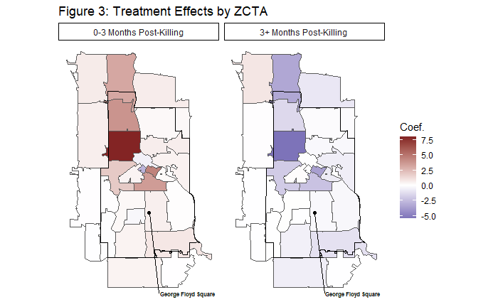

**Discussion**

We find that firearm assault injury rates increased after the murder of George Floyd by police, after statistically adjusting for seasonality, changes in police behavior, and COVID-19-related state policy changes. Further, our models indicate that changes in police behavior did not drive the temporal changes in gun assault injuries. These findings reveal a “Minneapolis effect,” wherein an extreme and high-profile police killing significantly altered the temporal pattern of firearm assault injuries. This is consistent with past research demonstrating similar effects, such as in Baltimore (10). Our study adds important information to this literature by using a measure of gun violence that is less prone to selection concerns. In addition, our analysis shows that communities already experiencing higher levels of social disadvantage and firearm incidence had disproportionate increases in firearm assault injury after the murder of Mr. Floyd. Further research is needed to elucidate these processes and their longer-term impact, but the pattern of findings is consistent with the idea that police violence impacts vulnerable communities by destabilizing social order and threatening public safety.

References and Notes

1. Muller, C. “Exclusion and Exploitation: The Incarceration of Black Americans from Slavery to the Present. *Science*, *374*(6565), 282-286 (2021).
2. Page, J., & Soss, J. “The Predatory Dimensions of Criminal Justice. *Science*, *374*(6565), 291-294 (2021).
3. Nummi, J., Jennings, C., & Feagin, J. “# BlackLivesMatter: Innovative Black Resistance.” *Sociological Forum* 34: 1042-1064 (2019).
4. Edwards, F., Lee, H., & Esposito, M. “Risk of Being Killed by Police Use of Force in the United States by Age, Race–Ethnicity, and sex.” *Proceedings of the National Academy of Sciences*, 116 (34), 16793-16798 (2019).
5. Jany, Libor and Liz Sawyer. “Gun Violence Soars amid Crises of Health, Public Trust, Officer Reluctance.” *Star Tribune*, June 20 <https://www.startribune.com/surge-in-gun-violence-tests-minneapolis-leaders/571524202/> (2020).
6. Shjarback, J. A., Pyrooz, D. C., Wolfe, S. E., & Decker, S. H. “De-Policing and Crime in the Wake of Ferguson: Racialized Changes in the Quantity and Quality of Policing among Missouri Police Departments.” *Journal of Criminal Justice*, *50*: 42-52 (2017).
7. Federal Bureau of Investigation. “FBI Releases 2020 Crime Statistics”. Retrieved 9/29/2021 ( <https://www.fbi.gov/news/pressrel/press-releases/fbi-releases-2020-crime-statistics>) (2021).
8. Rosenfeld, R. “Ferguson and Police Use of Deadly Force.” *Missouri Law Review*, *80*, 1077 (2015).
9. Pyrooz, D. C., Decker, S. H., Wolfe, S. E., & Shjarback, J. A. “Was There a Ferguson Effect on Crime Rates in Large US Cities?.” *Journal of Criminal Justice*, *46*, 1-8 (2016).
10. Morgan, S. L., & Pally, J. “Ferguson, Gray, and Davis: An Analysis of Recorded Crime Incidents and Arrests in Baltimore City, March 2010 through December 2015.” Retrieved 9/29/2021 (<https://osf.io/preprints/socarxiv/nshme/>) (2016).
11. Wu, D. T., Moore, J. C., Bowen, D. A., Kollar, L. M. M., Mays, E. W., Simon, T. R., & Sumner, S. A. “Proportion of Violent Injuries Unreported to Law Enforcement.” *JAMA Internal Medicine*, 179(1), 111-112 (2019).
12. Desmond, M., Papachristos, A. V., & Kirk, D. S. “Police Violence and Citizen Crime Reporting in the Black Community. *American Sociological Review*, 81(5): 857-876 (2016).

**Acknowledgments:** Not Applicable.

**Funding:**

Minnesota Population Center  P2C HD041023 (NJS)

Interdisciplinary Population Health Science Training Program T32HD095134 (NJS)

**Author contributions:**

Conceptualization: RPL, NJS, CU

Data Curation: RPL, NJS

Formal analysis: RPL

Funding acquisition: NJS

Investigation: RPL, NJS, CU

Methodology: RPL, NJS, CU

Project administration: RPL, NJS, CU

Resources: RPL, NJS

Software: RPL

Supervision: CU

Validation: RPL, NJS, CU

Visualization: RPL

Writing – original draft: RPL, NJS

Writing – review & editing: RPL, NJS, CU

**Competing interests:** Authors declare that they have no competing interests.

**Data and materials availability:** The majority of the data that support the findings of this study are readily available online, such as the American Community Survey, Minneapolis Police Department Data, Minnesota DNR Daily Weather Data, and Minneapolis School Calendars. However, the Minnesota Hospital Association data is restricted and cannot be publicly shared. However, requests for this data can be submitted (see supplementary materials for details). All code for analysis completed as a part of this study are also available in a GitHub repository (see supplementary materials for details).

Supplementary Materials

Materials and Methods

(Please delete before submission) Supplementary materials should be included in a separate supplementary materials file. A template for this file can be found at: <http://www.sciencemag.org/sites/default/files/Science_Supplementary_Materials_Word_template.docx>.

1. We construct linear time indicators at four key events in 2020: 1) the introduction of the Governor’s COVID-19 State of Emergency order (03/13/2020), 2) the introduction and conclusion of the Governor’s COVID-19 Stay at Home order (03/28/2020-05/28/2020), 3) the police killing of George Floyd (05/25/2020), and 4) three months following the police killing of George Floyd (08/25/2020).
2. Full model available upon request to the corresponding author.
3. A random effects specification with cross-level interactions indicates that the post-killing effect was significantly higher in ZCTAs with higher proportions of Black residents. Model is available upon request from the corresponding author.